Ideation Phase
Empathize & Discover

Date | 30 September 2026
Team ID | 6abab825ad6b12298106a1a8
Project Name | Import Data using Transform Maps (Spreadsheet)
Maximum Marks | 4 Marks

Import Data using Transform Maps (Spreadsheet)
Importing spreadsheet data into ServiceNow involves loading the file into an Import Set and using a Transform Map to map source fields to fields in the target table.

A Transform Map defines how data from the imported spreadsheet is transformed and placed into the correct ServiceNow target fields. It can also help create new records or update existing records.
The activity helps users understand the complete data-import flow: prepare the spreadsheet, load it into an Import Set, create field mappings in a Transform Map, run the transform, and verify the target records.
Process Flow:
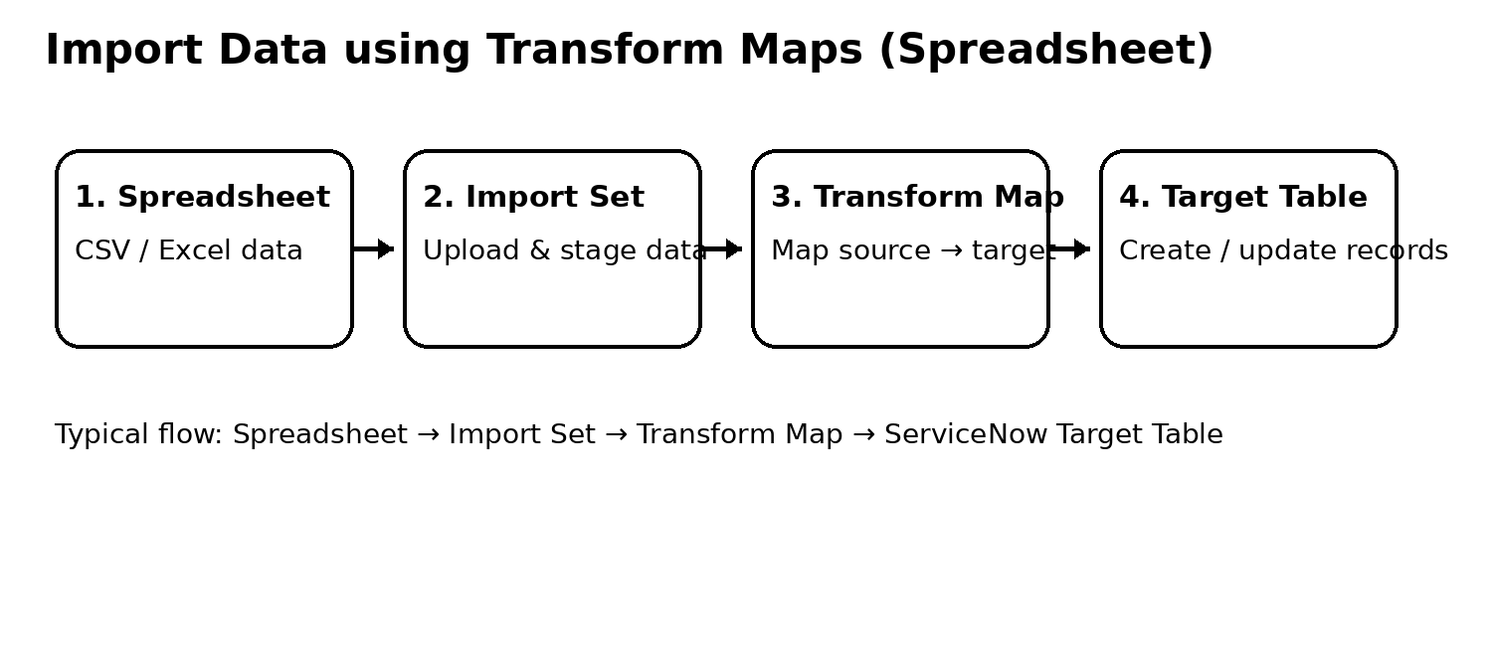

Example:
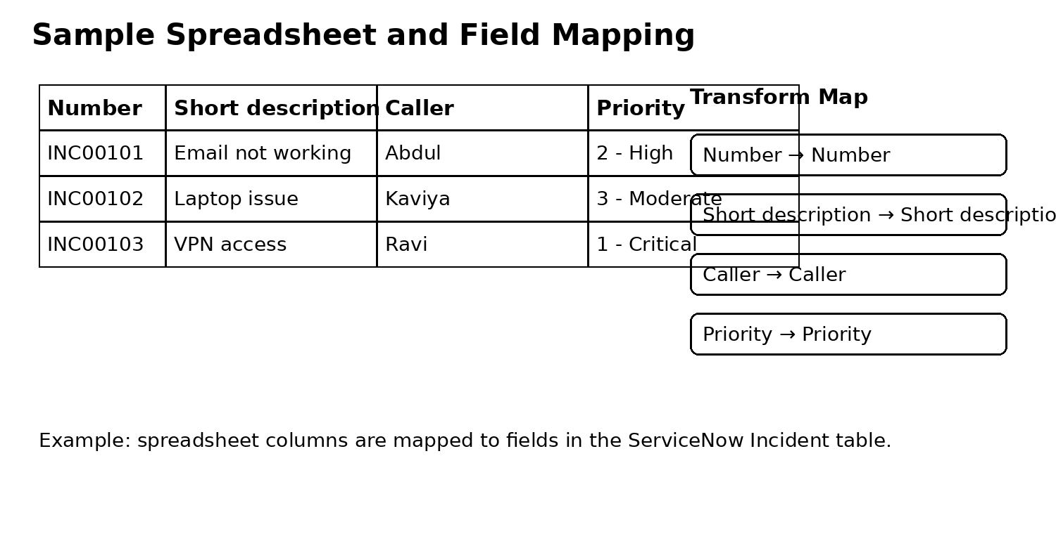

Example: Importing Incident records from a spreadsheet using a Transform Map.

Reference: ServiceNow Import Sets and Transform Maps

